- We expect the Monetary Policy Committee to hold Bank Rate at 3.75% at next week's meeting on June 18. The vote split will probably be slightly narrower than in April’s decision, with Megan Greene likely to join Huw Pill in voting for a hike due to shared concerns that second-round effects could prove larger than expected.
- Although energy prices remain elevated, most MPC members don’t appear close to voting for tighter policy. Early warning signs of indirect and second-round effects remain benign, and most members have argued that the weakness in the economy means the risks around the medium-term inflation outlook are two-sided. But these members are still likely to signal that they remain open to rate rises if necessary.
The Bank of England’s Monetary Policy Committee left Bank Rate unchanged at 3.75% at its last meeting on April 30. Although the meeting minutes and press conference accompanying that announcement suggested the MPC is in no hurry to tighten policy in the near term, the committee also made clear that the door to lifting Bank Rate remained open should energy prices stay elevated for a prolonged period or strong evidence emerge that significant second-round effects from higher energy prices were likely to form.
Since then, shipping through the Strait of Hormuz has remained severely disrupted, keeping commodity prices elevated. But the economic data have come in slightly softer than the MPC expected, while the early warning signs for indirect and second-round effects have remained benign. Against this backdrop, we expect the MPC to hold Bank Rate at 3.75% again at the June meeting, but with a slightly narrower vote split than in April and with the minutes signalling that most members remain open to tightening policy if necessary.
Chart 1: Oil and gas futures prices lie between the BoE’s middle and benign scenarios from mid-2027 onwards
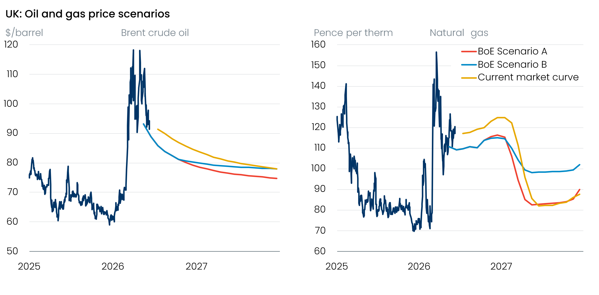
Sources: Oxford Economics, Haver Analytics, Bank of England April 2026 Monetary Policy Report

Recent data continue to point to a transitory energy shock
Key to the MPC will be monitoring how large the energy shock is likely to be, and what the implications for medium-term inflation prospects are. On that score, from mid-2027 onwards, oil and gas futures prices sit between the low and middle scenarios set out in the BoE’s April Monetary Policy Report (Chart 1). Given most committee members at the time suggested neither scenario required higher interest rates in response, energy price developments over the past six weeks are unlikely to have pushed them towards a more hawkish stance.
The limited amount of hard economic data published since April’s meeting has been relatively inconclusive. CPI inflation undershot the BoE’s staff forecast in April, which reflected both temporary factors and a genuine cooling in underlying price pressures in the services sector. It’s a similar story with April’s flash payrolls print. HMRC’s initial estimate of payrolled employees dropped by 100,000, but history suggests weak initial outturns for April tend to be revised smaller over time, and BoE Governor Andrew Bailey recently remarked that he places little weight on the flash payrolls estimates. Elsewhere, the latest pay data pointed to a further cooling in momentum, while May’s S&P Global survey suggested that economic activity has started to weaken.
The degree to which firms are responding to higher input costs by raising prices should become clearer as we move through H2 2026. But strong evidence on the scale of second-round effects via higher wage growth is unlikely to arrive until next spring, when data on the early 2027 pay round is published. This time lag leaves the MPC in a tricky position. As Bailey recently remarked, the committee can’t wait for hard evidence of second-round effects to emerge before acting, so policy must instead be set based on whether there’s a sufficiently high chance of these conditions materialising or not.
At this stage, most evidence suggests that indirect and second-round effects are likely to be relatively modest. Both the Citi/YouGov survey of household inflation expectations and the BoE’s Decision Maker Panel show that while year-ahead expectations remain elevated, medium-term inflation expectations are at similar levels to those seen before the Middle East conflict (Chart 2). Firms’ year-ahead wage expectations are also little changed. These results are consistent with the view that the impact of the energy shock is likely to be transitory, with only very limited upward pressure on inflation at the policy-relevant horizon.
Chart 2: Medium-term household and corporate inflation expectations remain close to pre-conflict levels
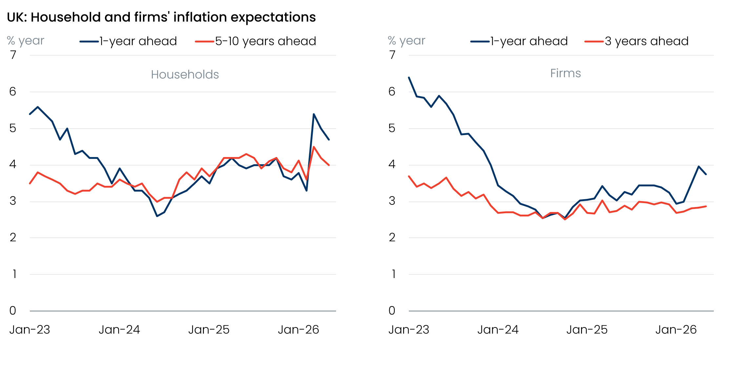
Sources: Citi/YouGov survey of inflation expectations, Bank of England Decision Maker Panel
Recent editions of the DMP survey have also included an additional question asking companies how they expect to respond to higher energy prices due to the Iran conflict. May’s release showed that corporates are overwhelmingly expecting more compressed profit margins, while only a relatively small percentage suggested they’re expecting to lift wages over the next 12 months in response to the shock (Chart 3). This should further ease the MPC’s concerns that the initial price shock will morph into a more prolonged period of above-target inflation.
Chart 3: Corporates overwhelmingly anticipate margin compression over the next year
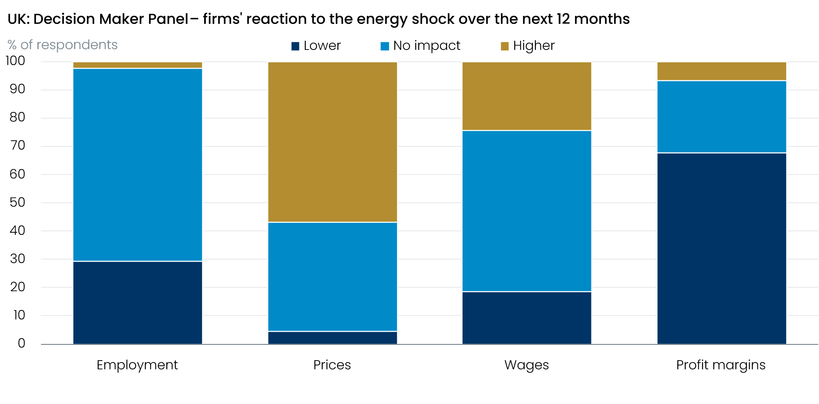
Sources: Bank of England Decision Maker Panel

Divisions within the MPC are rising, but the hawks don’t have the numbers
Every MPC member, apart from Deputy Governors Clare Lombardelli and Dave Ramsden, has made public comments since the April meeting to shed further light on their positions, but only one looks set to switch their vote.
In a speech last week, external member Megan Greene dropped several strong hints that she will vote to raise Bank Rate at the June meeting. Greene said she considered voting to hike in April but judged it would be a mistake if the conflict ended immediately. She also argued that it was most likely that the scale of second-round effects from the energy shock will land somewhere between the two higher inflation scenarios presented in April’s Monetary Policy Report, suggesting Bank Rate may need to rise by 75bps over the next 12 months. Her assessment on second-round effects revolves around analysis produced by BoE staff, which suggests that the impact of several recent negative supply shocks has left households and companies more sensitive to rising inflation than in the past, and longer-term inflation expectations more responsive to short-term inflation surprises.
We expect Greene to join arch-hawk Huw Pill in voting for a 25bp rate rise at next week’s meeting. But the other seven committee members don’t appear close to voting for tighter policy. These members have argued that the likelihood of significant second-round effects materialising remains relatively modest, that tighter financial conditions have already done some of the heavy lifting, and that the weakness of the economy and labour market means the risks to medium-term inflation are more two-sided than Greene and Pill have suggested.
Indeed, in a recent speech, Bailey said that he thinks “tolerating temporarily above-target inflation to provide some support for the real economy is an appropriate approach” to setting policy. These sentiments were recently echoed by external member Catherine Mann, who noted that the MPC has “wiggle room” in balancing its aim to keep inflation low while supporting the economy. Meanwhile, public remarks from Sarah Breeden, Swati Dhingra, and Alan Taylor suggest they remain relatively sanguine and that they view a strategy of holding Bank Rate at its current level as providing enough restrictiveness to keep a lid on inflationary pressures for now.

We expect a hold in June, with the committee signalling it remains willing to act if necessary
As of June 11, financial market pricing implies just a 7% chance of a 25bp rate hike at the June meeting. We agree that the likelihood of a hike next week looks low, given the balance of views on the committee and that none of the data published since April’s decision is likely to have pushed members in a more hawkish direction. Therefore, we expect the MPC to vote 7-2 to hold Bank Rate at 3.75% in June, with Greene joining Pill in preferring a 25bp increase.
Nevertheless, we think those advocating for a hold at next week’s meeting will signal that they remain open to tightening policy later this year should energy prices remain high for a prolonged period, or if it looks more likely that strong second-round effects will emerge. So, although our baseline forecast assumes Bank Rate will remain on hold for the rest of this year, risks are skewed towards tighter policy. In our view, current market pricing reflects this balance of risks (Chart 4).
Chart 4: Market pricing implies a June hold is a near certainty, but some tightening later this year is still a risk
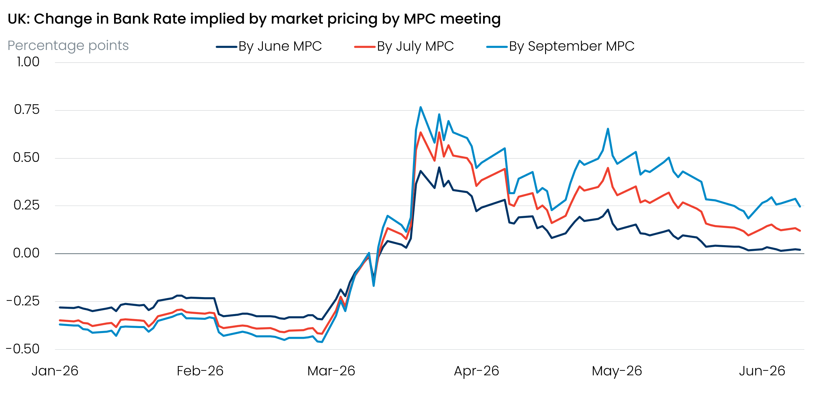
Source: Oxford Economics calculations using data from Haver Analytics

